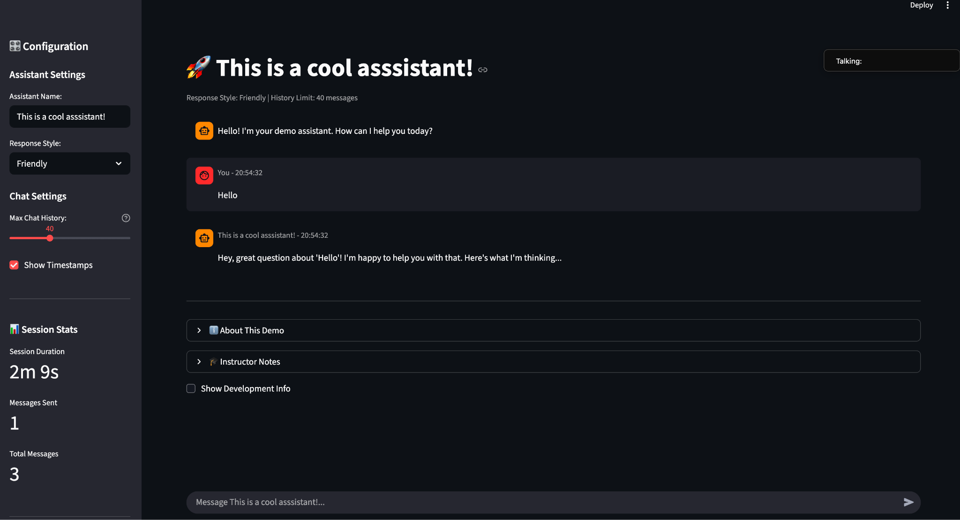

Prerequisites 👍  
  
1. Streamlit >=1.28.0

2. pip/python installation

3. VSCode

**Problem Statement :   
  
Chat bot interface**

**Sidebar Configuraation**

**Session Stats (Duration)**

**Action : Clear the chats/ Export the chat as downloadable (.txt)**